CPE301 – SPRING 2021

Design Assignment 2B

Student Name: Elmer Mejia

Student #: 5003824808

Student Email: mejiae4@unlv.nevada.edu

Primary Github address: https://github.com/cpemejia/design_assignments.git

Directory: design_assignments

1. **COMPONENTS LIST AND CONNECTION BLOCK DIAGRAM w/ PINS**

-Atmega328pb - Multi-function shield -KiCad

-Microchip Studio -Logic Analyzer

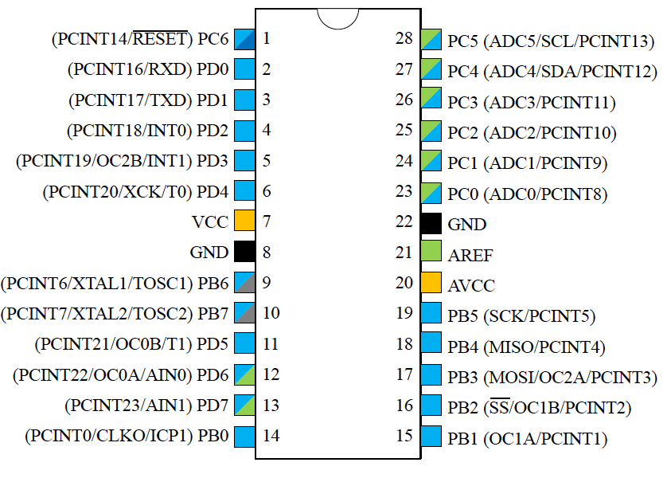



1. **INITIAL/MODIFIED/DEVELOPED CODE OF TASK 1/A**

;

; DA_2B.asm

;

; Created: 2/27/2021 1:32:34 AM

; Author : ElmerOMejia

;

; Replace with your application code

.include <m328pbdef.inc>

.ORG 0x00 ; reset location

RJMP MAIN

.ORG 0x02 ; external interrupt 0 location

RJMP EX0_ISR

MAIN:

LDI R20, HIGH(RAMEND) ; initialize stack

OUT SPH, R20

LDI R20, LOW(RAMEND)

OUT SPL, R20

LDI R21, 0x02 ; INT0 is falling edge

STS EICRA, R21 ; set 2 into EICRA register

SBI DDRB, 3 ; set PB3 as output

SBI PORTD, 2 ; pull up on PD2

LDI R21, 1<<INT0; INT0 enabled

OUT EIMSK, R21

SEI; enable interrupts

loop:

CBI PORTB, 3 ; turn on portB

LDI R22, 15 ; delay 15x

CALL delay ; call delay subroutine

SBI PORTB, 3 ; turn off portB

LDI R22, 5 ; delay 5x

CALL delay ; call delay subroutine

rjmp loop ; endless loop

delay: ; delay for a 0.05s delay

LDI R16, 3 ; load immediate 3 to R16

L1: ; label 1

LDI R17, 105 ; load immediate 105 into R17

L2:

LDI R18, 255 ; load immediate 255, into R18

L3:

NOP ; NOP for more delay

NOP

NOP

NOP

NOP

NOP

NOP

DEC R18

BRNE L3

DEC R17

BRNE L2

DEC R16

BRNE L1

DEC R22

BRNE delay

RET

EX0_ISR:

SBI PORTB, 3 ; led pb3 off

SBI DDRB, 2 ; output PB2

CBI PORTB, 2 ; led pb2 on

LDI R22, 40 ; 2s delay

CALL delay

SBI PORTB, 2 ; led pb2 off

RETI

/*

* DA_2BC.c

*

* Created: 2/27/2021 11:57:51 PM

* Author : ElmerOMejia

*/

#include <avr/io.h>

#define *F_CPU* 16000000UL

#include <util/delay.h>

#include <avr/interrupt.h>

int main(void)

{

DDRB |= (1<<PB3); // set PB3 output

PORTB |= (1<<PB3); // set PB3 off

PORTD = 1<<2; // pull up enable

EICRA = 0x02;

EIMSK = (1<<INT0); // enable interrupt 0

sei(); // enable interrupts

while (1)

{

PORTB &= ~(1<<PB3); // output PB3 on

*_delay_ms*(750); // delay of 0.75s

PORTB |= (1<<PB3); // output PB3 off

*_delay_ms*(250); // delay of 0.25s

}

}

ISR (INT0_vect) // ISR for INT0

{

PORTB |= (1<<PB3); // output PB3 off

DDRB |= (1<<PB2); // set PB2 output

PORTB &= ~(1<<PB2); // output PB2 on

*_delay_ms*(1750); // delay of 2s

PORTB |= (1<<2); // PB2 off

}

1. **SCHEMATICS**

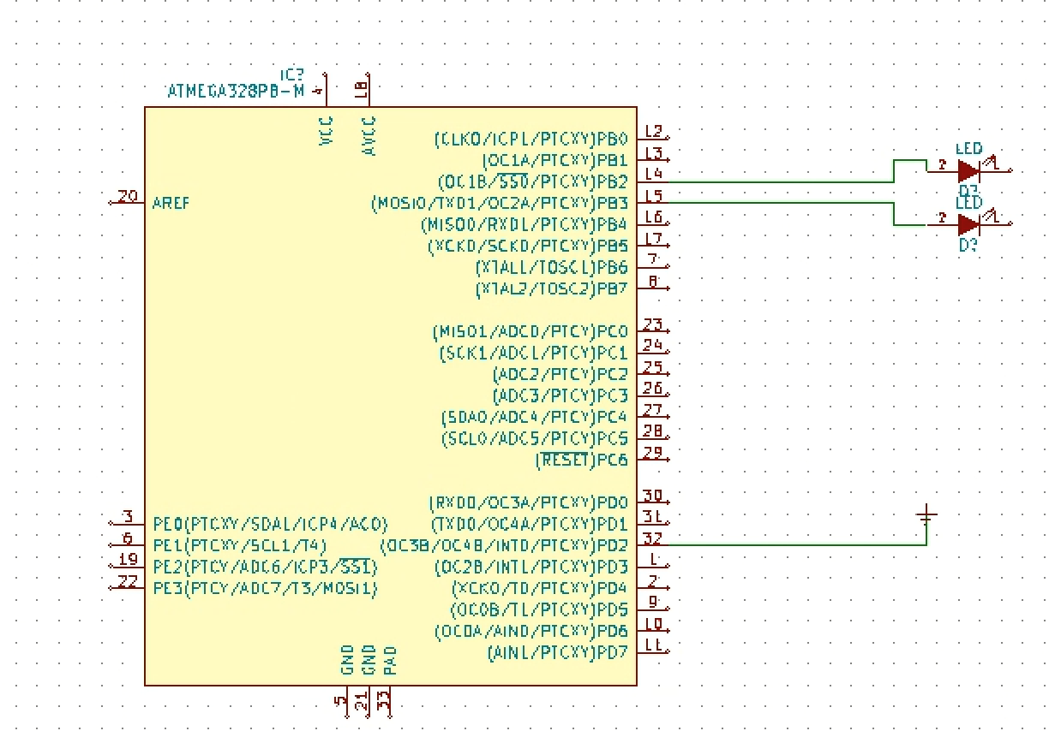

1. 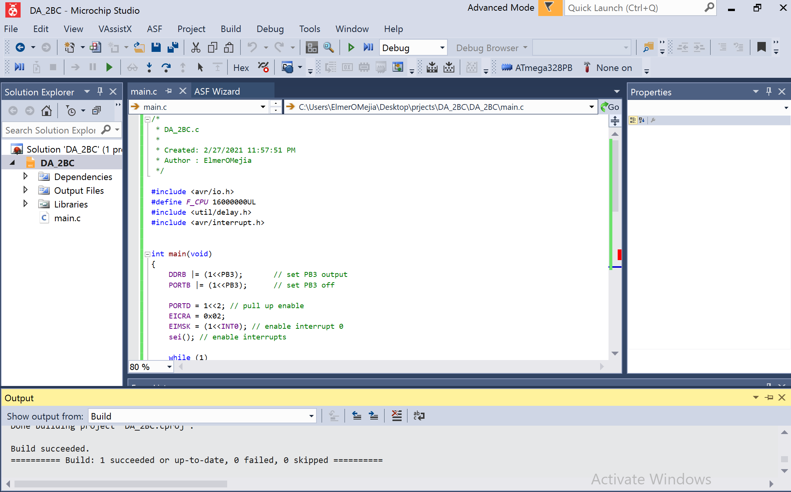**SCREENSHOTS OF EACH TASK OUTPUT (ATMEL STUDIO OUTPUT)**

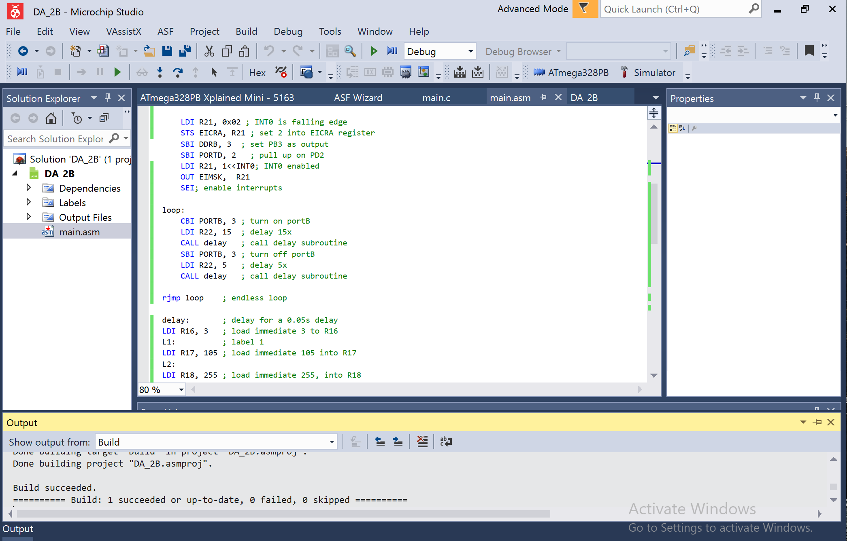

1. **SCREENSHOT OF EACH DEMO (BOARD SETUP)**

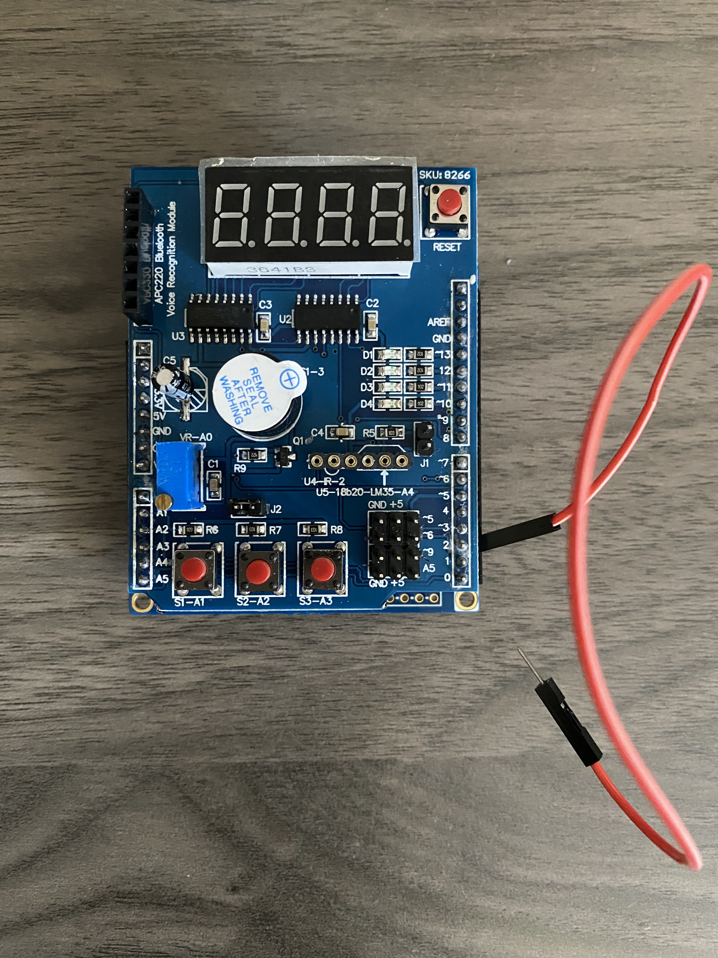

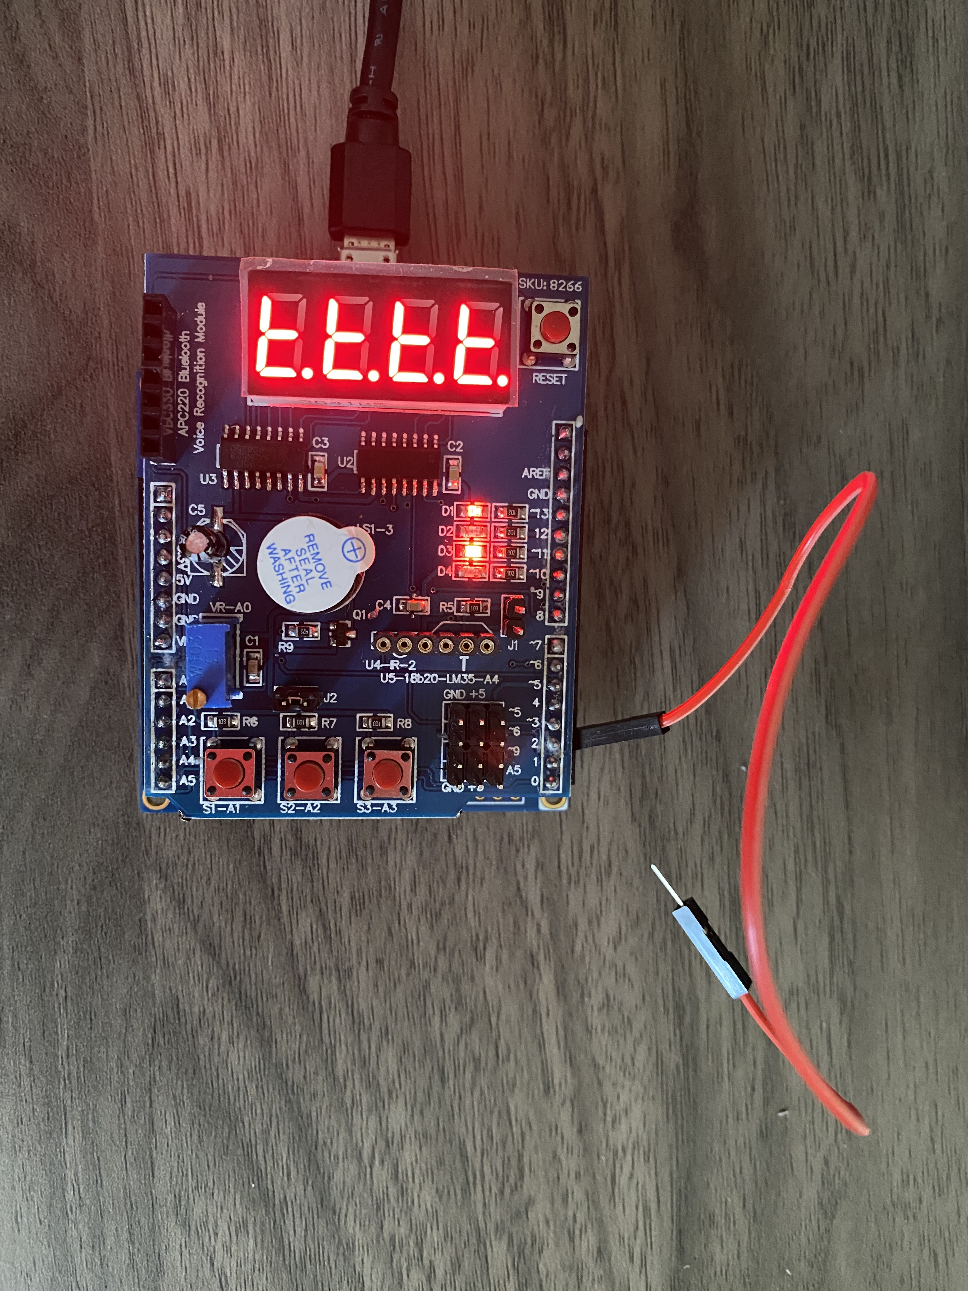

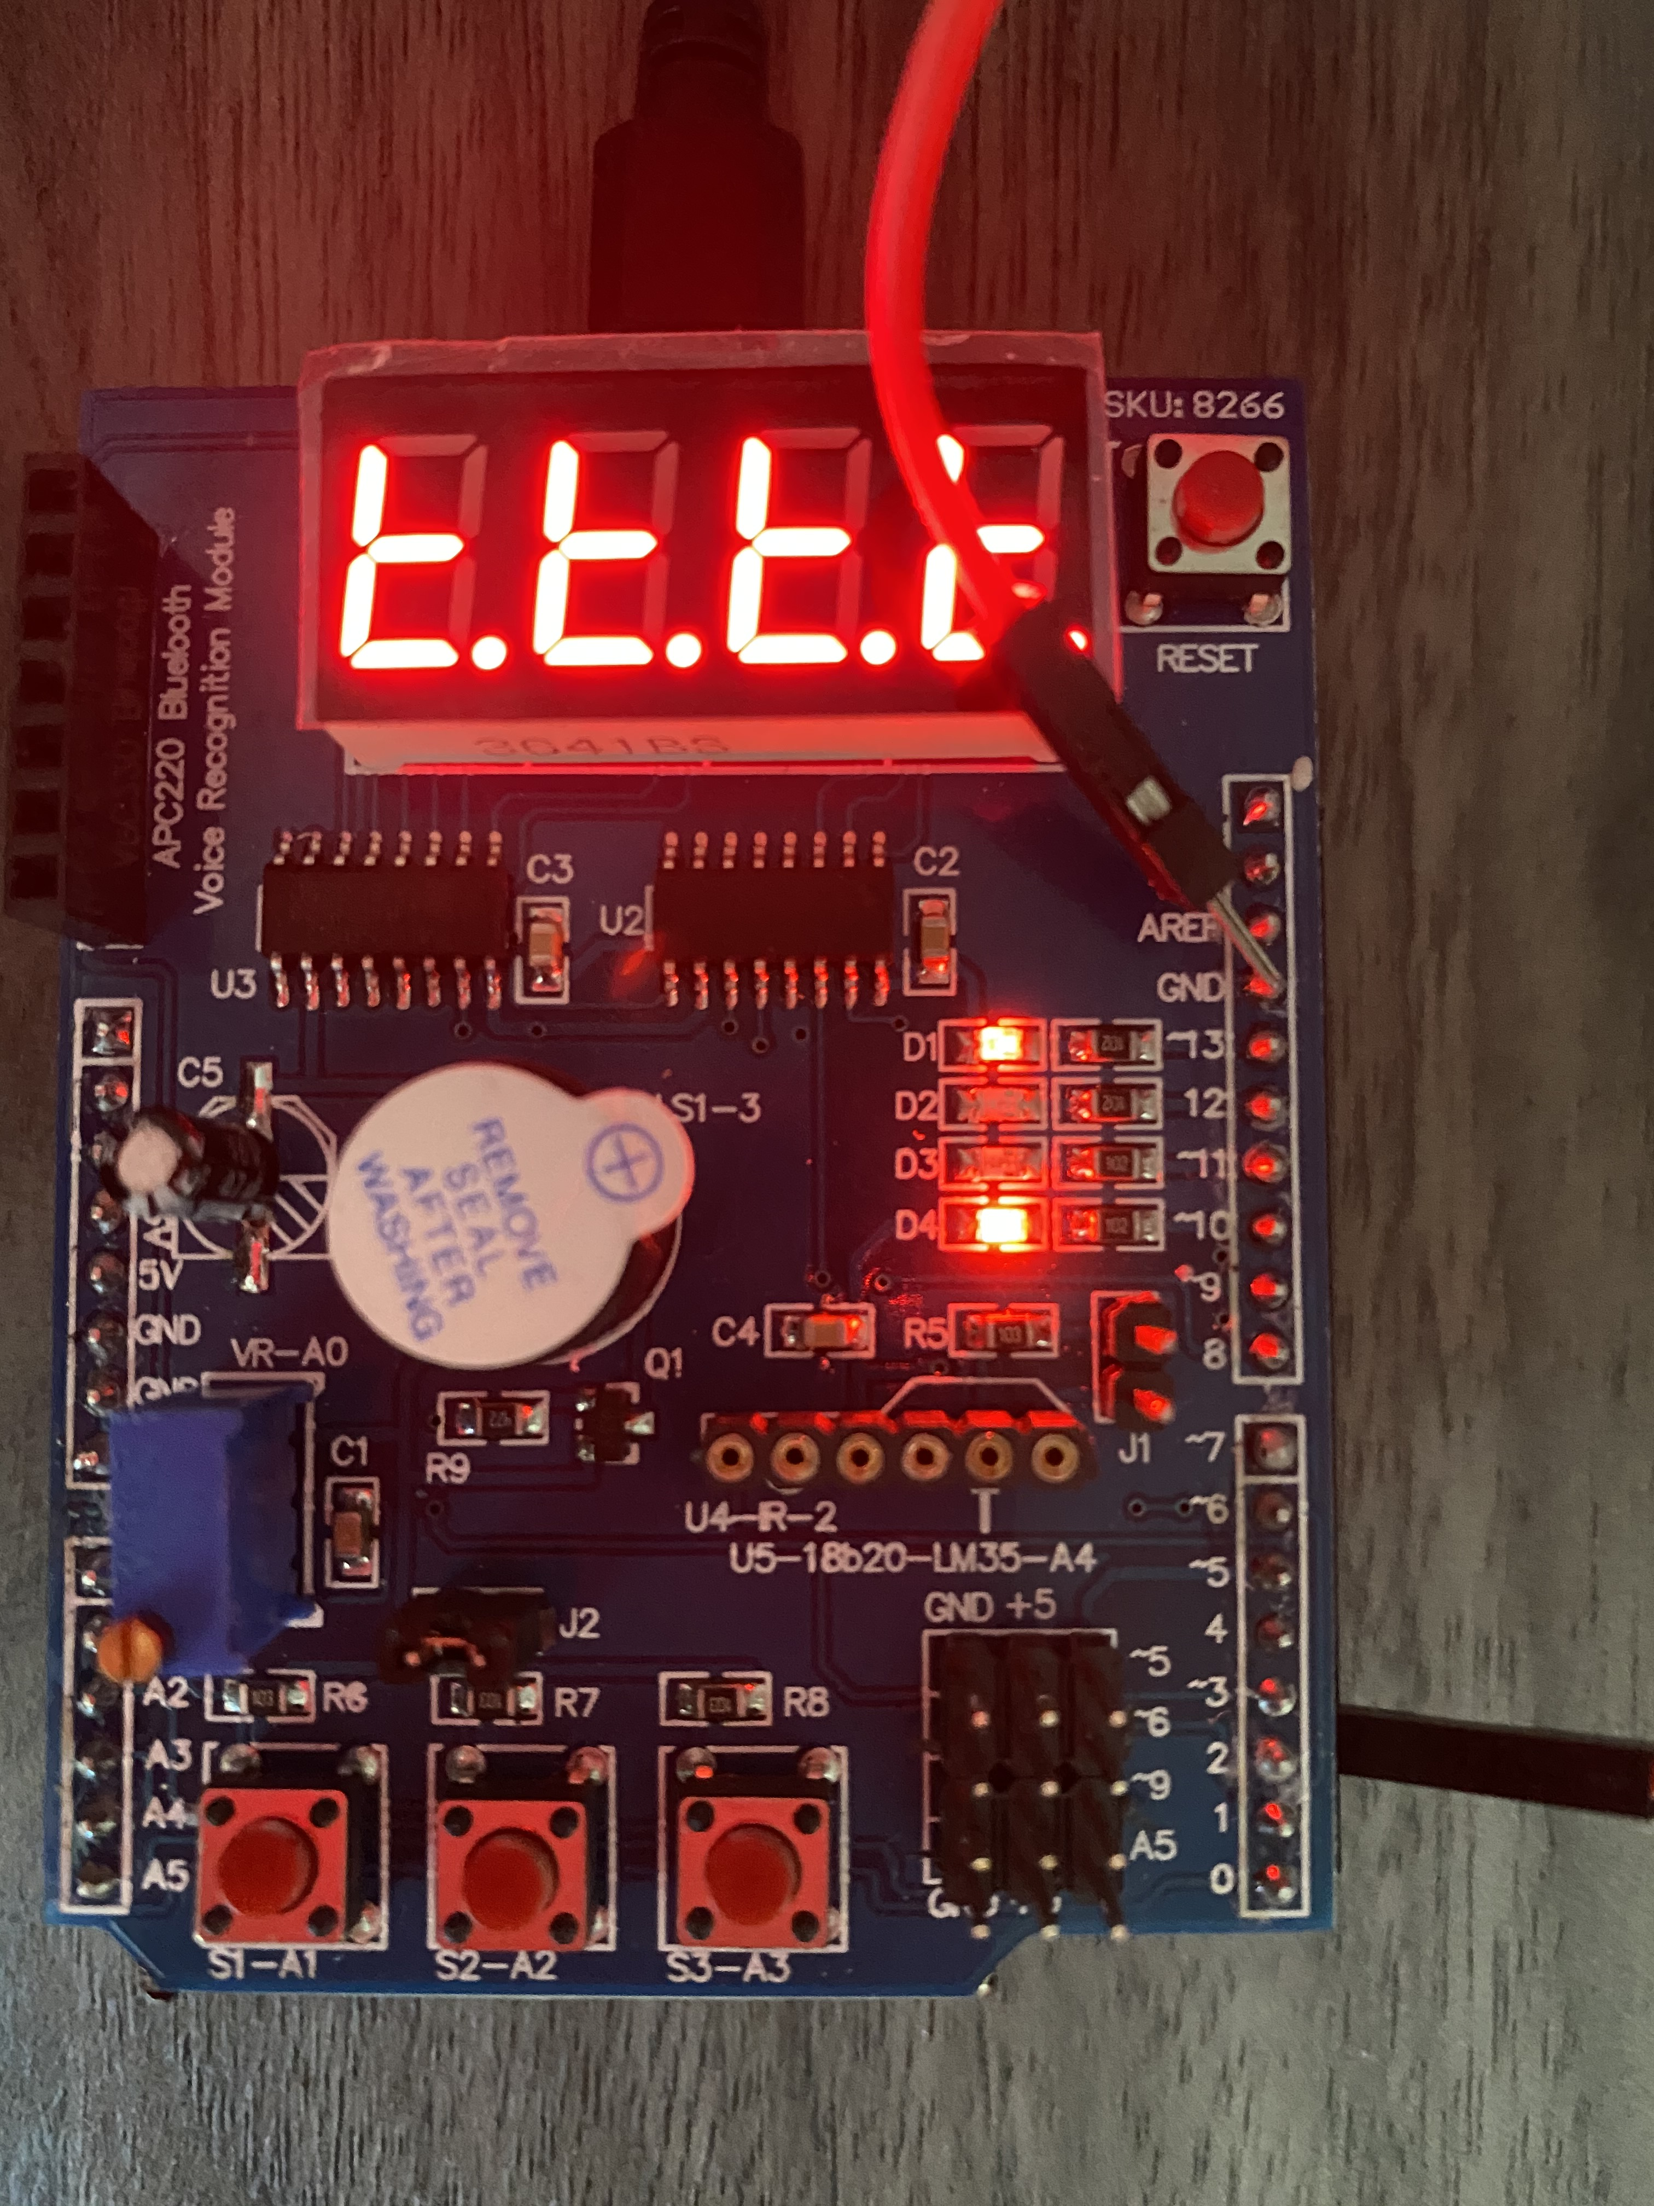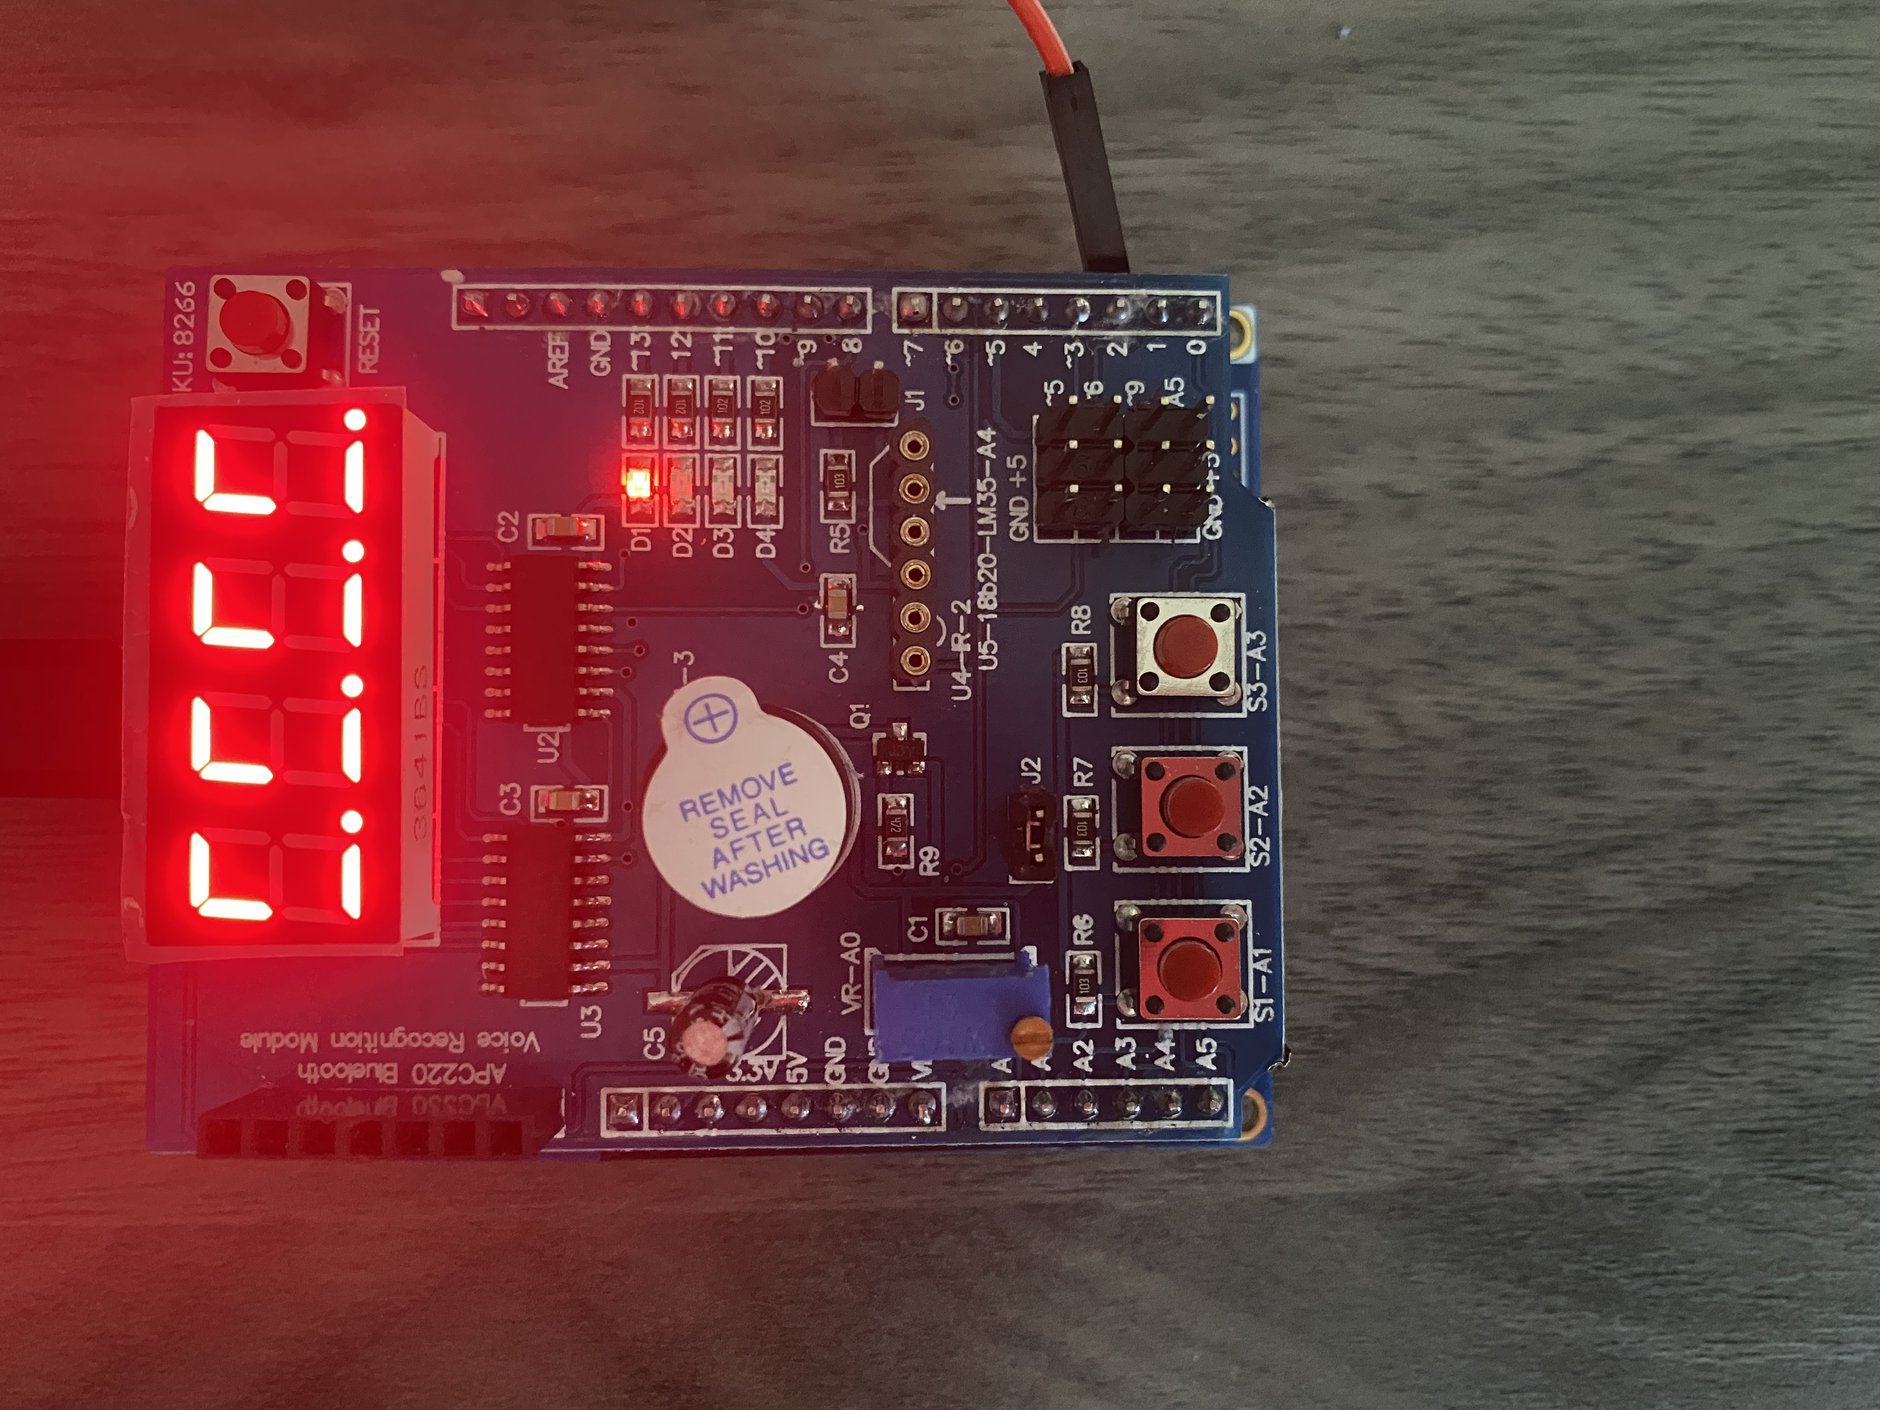

1. **VIDEO LINKS OF EACH DEMO**

[Design_Assignments - YouTube](https://www.youtube.com/playlist?list=PL6PbL2NpuYCKbUNnRQzdehoDwvBhUNAA1)

1. **GITHUB LINK OF THIS DA**

https://github.com/cpemejia/design_assignments.git

**Student Academic Misconduct Policy**

<http://studentconduct.unlv.edu/misconduct/policy.html>

“This assignment submission is my own, original work”.

Elmer Mejia